MINUTES OF THE MEETING OF THE BISLEY-WITH-LYPIATT PARISH COUNCIL HELD ON WEDNESDAY 2 MARCH 2022 AT BISLEY VILLAGE HALL

Present Chairman Mike Eccott ME
Bisley Ward Lesley Greene LG
Dave Partridge DP
Hazel Saunders HS
Eastcombe Ward Jenny Exley JE
Louie Wilkes LW

Oakridge Ward Roger Budgeon RB
Helen Jones HJ
Tony Martin TM

Clerk Mrs D Meredith

1. Apologies for absence. DR, MB and SW.
2. Declarations of interest. None received.
3. Approval of the Minutes of the Meeting held on 9th February 2022 at Bisley Village Hall. Carried.
4. Matters and actions arising from the Minutes not otherwise covered in this agenda. Clerk confirmed she has ordered the plaques for the jubilee trees. JE queried receipt of the playground quote for Eastcombe – Clerk has raised this with company concerned.
5. Co-option of H Jones as new Parish Councillor by RB for Oakridge Ward representing Waterlane. RB proposed that HJ is co-opted onto the Parish Council as member for Oakridge Ward. TM seconded. Carried.
6. Public Participation - Members of the public are invited to address the Council. No members of the public were present.
7. County Council Matters – distribute a report from County Councillor Sue Williams – Annex A to these minutes.
Due to late receipt of an email from SW, ME asks that the council reads and send their response to the Clerk for collation and submission. The cost of installing cycle tracks is very expensive but LG queried the cash required for roads vs climate change and would like to ask SW why it is so? ME commented on the proposed relocation of Stroud library to the lower ground floor of the new development at the Poundland site in Stroud. A survey is running until 25th April for comments.
8. District Council Matters – distribute a report from District Councillor Martin Brown. ME read out detail from his short resume. Annex B in these minutes.
9. Agree the Parish Council Response to the following Planning Applications
a) S.22/0248/TCA - Greystones, Dr Crouchs Road, Eastcombe - T1- Reduce in height to 11m and reduce girth proportionate to new height T2- Removal of lower limbs T3- Reduce height to 9m and reduce girth proportionate to new height – Support.
b) S.22/0267/TCA - Lark Rise, Wells Road, Eastcombe - Willow to be pollarded. Tasmanian Cedar to be removed. Holly trunk under overgrown hedge to be removed – Varied response to individual trees so overall objection.
c) S.22/0326/VAR - St Marys, Eastcombe, Stroud - Variation of Condition 5 of S.21/2834/VAR - Removal of wording – no comments.
d) S.22/0335/HHOLD - Weir Farm, Oakridge Lynch, Stroud - This is a top up application for approved application S.17/1409/HHOLD. No changes have been made. Support with conditions that it should always remain within the existing building curtilage.
e) S.22/0375/TCA - Sylvanus, Eastcombe - To pollard 4 trees on site – comments only.
f) S.22/0374/TCA - Parkview, Eastcombe - T1 Cypress Lawson - Removal due to damage to roof – support.
g) S.22/0346/AGR - Creation of a 1m deep freshwater pond habitat - Land Parcel To South Of Lower Battlescombe Farm Hayhedge Lane Bisley – debated whether it is something we consult on as it is AGR but LG requested that it be on the agenda as a positive project, fulfilling climate emergency nature recovery so support.
10. Matters for Discussion:
a) Dark Skies policy – RB wishes to reinforce our policy and bring it to the fore. The latest CPRE newsletter asks us to count the stars to measure dark skies currently. Clerk to read current information on the CPRE website and write up and add to April’s agenda.
b) Tree policy update – LG – draft policy has been issued as a result to clarify the Parish Council’s position regarding liability on public land. LG to send a copy to HJ. RB proposed support as this covers trees within PC remit. The new Oakridge trees are in Waterlane and the PC does not have any responsibility for them. RB asked if RA could stake oak in allotments – Clerk to request. The updated Policy was adopted and Clerk to upload to the website.
c) Bugs Bees and Broccoli allotment and garden wildlife focus survey approval – LG – requests that the PC will put this survey on the website and issue to all allotment holders when it comes out. Carried – Clerk to action when issued.
d) Government consultation on the Glover Landscapes Review – an opportunity to stop ‘off-roading’ in AONBs – HS – thought it would stop off roaders in Joiners Lane, but realises that this for responses to a complicated survey, so not of much help. The survey can be accessed to stop off-roading in an AONB. LG agreed as off- roading is an issue in Catswood and RB said also in Oakridge. Every case against off roaders has been lost in law so it was suggested about writing to the MP on this issue, copying in GCC and SW. DP said they have more funds to fight it than Highways. RB said access is important to retain but LG and HS disagreed as farm vehicles do not always require access, eg Joiners Lane. DP said care should be taken for farmer access and land maintenance. HS to draft a response for formal approval next month.
e) CPRE Great Spring Clean – HS – apologies for difficulty with the link but wished to draw attention the event.
f) 2023 Parliamentary Boundary Review - Second Consultation- ME – Letter already issued at first consultation, asks if we resubmit or amend? LG thought it was good and wanted to add elderly/social care in the Stroud Locality. ME suggests that if councillors wish to add anything, send to Clerk soonest for resubmission before 3rd April for the 4th April deadline.
g) Discussion on footpath obstruction from Mount Pleasant, Holloway Road to High Street, Bisley – LG – an overview was given that in the autumn a fence was erected alongside the footpath from Mount Pleasant to the High Street. It is not formal footpath but is regularly used by residents in order to avoid walking along the back road. The new owners of the cottage that faces High Street with the garden rising parallel to the path have erected a high fence with posts outside the boundary wall. Last week she was called by a resident who accesses the path with children and was concerned as during the winds, buttress posts were put against the fence blocking the path. LG went to see the fence with another resident trying to negotiate them and tried to contact the owner. The Clerk has received emails on this subject so it has been brought to the PC to discuss. Residents don’t appear to have spoken to the new owners and one resident has now removed these supporting posts as couldn’t walk the path. Today LG met the owner, talked to her and explained the situation. She had erected the posts due to the high winds and concern that the fence would blow down. The fence is bowed and LG feels it is unsuitable. The owner stated that no-one has spoken to her on this topic, police had been informed and she felt unwelcome. LG is concerned about the health and safety of villagers and asked her to attend this meeting if possible. Regarding the status of the path – GCC is responsible for paths and 4 years ago HS proposed that it was added to the definitive map but at that time had no support from the residents as the path goes past their front doors. LW stated that this is assumed access as it goes to the properties. TM stated that this is a civil matter as there is no owner of the path. LG asked that if the owner of the house felt the fence was unsafe and needed buttress posts, is it therefore unsafe and does the PC have an obligation to have an structural assessment to ensure residents are not endangered when using the path? ME responded that as this path is not PC land then we cannot get involved. HS remarked that it is the fence owner’s responsibility and they are liable. LG asked if it is PC responsibility to inform the owner of that? LW stated that if residents don’t complain about the post siting then assumed rights won’t happen and they should write to the owners to object. ME reiterated that the PC should not be involved unless to address if it should be made an official footpath. DP said that that would increase its use by walkers. If the PC gets more formal complaints then a different response would be discussed. LG stated that due to article 4 of the conservation area on the High Street means that planning permission should have been applied for as the fence is erected above the bank and high up on a relevant frontal location adjacent to the highway which contravenes this article. ME asked that LG drafts documents to be sent to MB to address on his return. Clerk to respond to public complaints via email – LG and Clerk to draft. HS said we can start the procedure to get adopted on the definitive map. RB seconded. Clerk to process.
11. Finance:
a) Approve monthly payments of account (details to be circulated) – carried. JE queried the stone walling costs and are the figures lining up with the invoice and quote. Clerk and RB explained that all is as agreed.
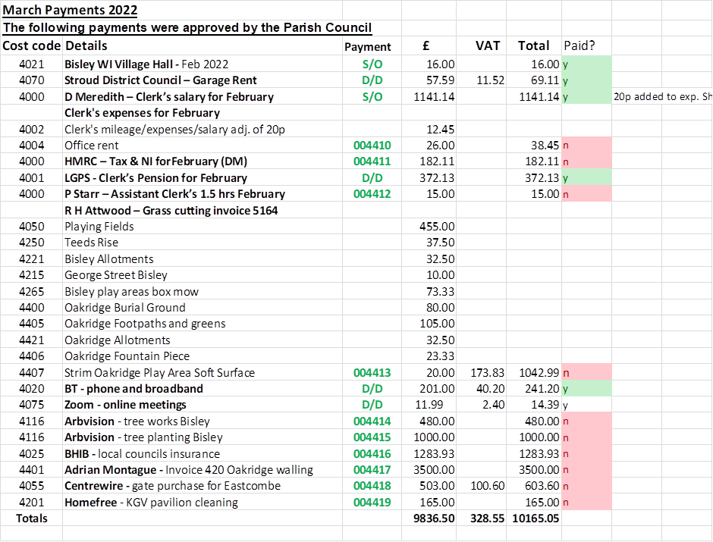
12. Correspondence – Clerk to report – Informed the meeting that she has been update by email about potential increases in grounds work from RH Attwood due to fuel increases. Additionally the PC has received thanks for the works to Oakridge Church wall from the Church Warden who particularly praised the quality of the walling and the way the works were achieved.
13. Ward Reports – Ward Chairmen to report on Ward matters
Bisley Ward - HS informed the meeting that cricket may soon be back on the playing field in Bisley but having looked at the field, the current 9-a-side pitch, in use at the moment, would need to go. See how that one goes forward. LG reminded the meeting of Teeds Rise dates with GWT clearing for the hedge line. On 1st April volunteers are to plant a Woodland Trust hedge and surplus plants will be offered to Eastcombe to create small hedge on the recreation ground adjacent to TK School. JE and ME think this is a nice idea and TK students will help planting. Clerk offered to measure the length.
Eastcombe Ward JE - stated that she has no further information on finding a burial ground with no information from Chalford to date. Tried to track down for the NDP about costs of fees that planning would be charging. St Mary’s has another condition issue coming up before next meeting and her response will be circulated prior to the next meeting. LW apologised as she has not managed to understand which farm is letting off the crow scarer. DP said possibly land between Oakridge and Eastcombe. ME has had emails from residents about hedges overhanging roads but feels not much can be done about it. ME was going to put that into newsletter re-policies. A report about the footpath between Bismore and Fidges Lane which has dangerous broken barbed wire on it which ME will investigate and report for next month. He suggested the resident contacts Cotswold Wardens.
Oakridge Ward - RB reported on the position of seat installation for Cherry Piece, HJ said tree work not done, so waiting on that and that she has spoken to DR who is happy to keep them for now. Observation for the Bisley Ward, more sheep killed by dogs walking towards Lypiatt. Reinforcement required that dogs need to be under control. Professional Dog Walkers are also an issue. JE asked is that is a PCSO issue. He reported ongoing problem with the land off Limekiln Lane, carrying out an industrial building materials waste crushing process on the land. HJ said county are aware from Stroud about the issue and she has been asked HJ to make a report about it today. Planning enforcement would try to take it up.
14. Date/location/format of Next Meeting – Chair - April 6th at Bisley WI Village Hall for the SDC Planning forum at 7:30pm.
The Annual Parish Meeting will be at 7:00pm on 13th April with the Ward Chairmen’s, Clerk’s and NDP reports followed by the full Parish Council meeting at 7:30pm, both at Bisley WI Village Hall.
The Chairman thanked the Clerk for her efforts as it was her last meeting.

Annex A.
Report from County Councillor.
County Councillors report for March 2022
Council approves £521 million 2022/23 budget

The budget is an increase of more than £38 million on 2021/22 levels and was approved by Council at a meeting on Wednesday, 16 February.
Funding has been agreed for 26-miles of cycle track from Stroud to Bishop’s Cleeve, investment into our market towns and high streets, and ongoing support and protection of the most vulnerable in our communities
As well as this, the budget also includes:
- £100 million for our roads
- £150 million investment into school buildings in Gloucestershire
- £14 million investment into Children and Young People’s Services
- £1 million per year to tackle climate change
- £20 million invested into cycle routes across the county
- £9 million extra to support vulnerable adults and those living with a disability
- More investment into Gloucestershire Fire and Rescue Service
Despite the extra investment, the council is still expected to have one of the lowest council tax levels of any county council.
The budget will raise around £10.2 million to help fund services through a council tax increase of 1.99%. We will also apply the national social care precept at 1% to raise an additional £3.7 million to support the thousands of vulnerable adults we work with each year. Based on a band D property, this equates to a £3.50 monthly increase.
Cllr Mark Hawthorne, leader of Gloucestershire County Council, said: “This is a budget that will begin building back better for Gloucestershire.
“It features investment into our county to help our communities recover after the impacts of the COVID-19 pandemic, and also invests in the future of Gloucestershire by putting the climate emergency at the heart of what we do, to allow us to work to create a Greener Gloucestershire.
“I am proud of what we have been able to achieve in this budget, while also delivering one of the lowest council tax levels of any county council in England.”
Amendments to the budget which were approved by Council include:
- An additional £250,000 to Community Speedwatch, making a total of £550,000
- £33,000 to prevent increases to the costs of parking permits
- £45,000 to pay for a biodiversity management officer to identify opportunities on Council land
- £120,000 to establish a recycling shop pilot at one of the county’s household recycling centres
- £100,000 to reserve for traffic regulation orders (TRO)

26-mile ‘cycle spine’ through Gloucestershire has been revealed.
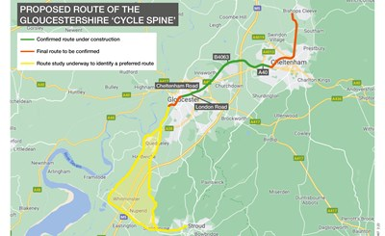

The proposed route of the 26-mile ‘cycle spine’ through Gloucestershire has been revealed.Extending from Stroud to Bishop’s Cleeve, the map shows how the route would pass through Gloucester and Cheltenham, creating a substantial cycling and walking network through the county.
Funding has already been committed to link Gloucester city centre to Cheltenham, with a route along the B4063.This will be extended to the north with a route through Cheltenham, and on to Bishop’s Cleeve. While, to the south the route will extend as far as Stroud, with work underway to identify the most appropriate route.
Sections of the route to the south of Gloucester city centre and to the north of Cheltenham are yet to be confirmed. However, proposals are in the process of being developed and funding has been committed to undertake further design. Residents will be consulted on the proposals once the plans are at a more advanced stage.
The county council is committed to tackling climate change and creating a Greener Gloucestershire.
Investing in cycling and walking infrastructure will help us work towards a Greener Gloucestershire by improving air quality and reducing carbon emissions from transport. Cycling and walking also improves the health and wellbeing of our residents
Cllr David Gray, Cabinet member responsible for Environment and Planning at Gloucestershire County Council, said: “This map is a commitment by the council to invest in methods of sustainable transport across the county.
“Our long-term vision of an unbroken cycle route from Stroud to Bishop’s Cleeve will allow cyclists and pedestrians to access our county through more sustainable modes of travel.
New support service for adults bereaved by suicide

The new service which will be provided by Rethink Mental Illness, will give support predominantly to families and partners, however support will also be available for friends, colleagues, health and social care professionals, and those who may have witnessed the death. Support will be tailored to the individual’s needs.
The service is being funded through NHS England/Improvement’s national suicide bereavement programme.
The support offered to adults bereaved by suicide includes:
- 1:1 emotional and practical support beginning with six personalised weekly sessions with a Suicide Bereavement Worker, followed by six fortnightly sessions, and an option to extend if needed
- Practical support including help to navigate processes such as talking to police, funeral arrangements, Coroner's Court and inquests, responding to media and support to talk to employers
- Bereavement counselling with volunteer counsellors, beginning with six to eight weekly sessions
- Face to face and virtual bereavement peer support groups facilitated by a Suicide Bereavement Worker and a volunteer with lived experience of suicide. These will help people build connections, tackle the isolation they may be feeling and get support from others with similar experiences
- Signposting and referral to other bereavement services as appropriate.
All support is delivered through a mixture of face to face, virtual channels, phone, email and text to suit the individual’s needs.
Everyone who uses the service has ongoing access to an exclusive online Gloucestershire bereavement by suicide forum hosted by a mental health online peer support platform called Clic. This moderated forum is available 24/7 to help people share experiences and gain peer support.
Professor Sarah Scott, executive director of adult social care and public health at Gloucestershire County council said “Losing someone to suicide causes intense grief and emotional distress for everyone impacted by the loss, and it can have a ripple effect which extends well beyond immediate family and friends.
“We want to make sure that everyone bereaved by suicide can get the support they need, when they need it and in a way which works for them.”
Cllr Tim Harman, cabinet member for public health at Gloucestershire County Council said: “Suicide is a tragedy for the person and their family and friends, leaving lives devastated.
“It’s important that everyone bereaved by suicide is able to access the right kind of sensitive support. I’m pleased that our new service with Rethink Mental Illness will be able to give people the personalised practical and emotional support they need to come to terms with their loss, during what is a very traumatic time in their lives.”
Dr Mala Ubhi, GP and Clinical Lead for Mental Health at NHS Gloucestershire Clinical Commissioning Group, said: “People bereaved by suicide often express feelings of isolation and loneliness, so offering them support when they are particularly vulnerable and hurting is really important in helping them to cope and recover.
“This service will help those who are struggling to know that they are not alone, that what they are experiencing is normal, and that there is hope for the future.”
Janice Laverick, Service Manager, Gloucestershire Support after Suicide Service, said: “After a bereavement by suicide, people not only have to come to terms with a range of complex and powerful feelings of grief; they will also be navigating a range of practical challenges.
“We’re here to provide support at one of the most difficult times in people’s lives, when they might otherwise feel lost or isolated in their grief. We’d encourage people in Gloucestershire who’ve been affected by suicide to reach out to us for support.”
To find out more about the service or make a referral for yourself or someone else, please call 07483 375 516, email glossupportaftersuicide@rethink.org or visit: www.rethink.org/glossupportaftersuicide
Over 6,500 pupils offered secondary school place

On Tuesday, 1 March, parents of pupils going to secondary school in September 2022 will receive a place from Gloucestershire County Council. All parents in the county will be offered one school place for their child on the same day.
Parents will have until 8 March to accept their school place or request an alternative school. The 97 per cent of parents and carers who applied online will receive an email confirming their school place after 9am on 1 March and will be able to accept their place online.
As well as the 86 per cent being offered their first preference school, 95 per cent are being offered one of their preferences.
Those parents or carers who did not apply online should receive a letter on Monday, 1 March, including the place on offer and the reasons why. This letter will be specific to each pupil and will contain an explanation for the decision made.
Parents are encouraged to accept their place online or return their reply forms as soon as possible. As we know from previous years, more places are likely to become available over the next few months as parents change their preferences.
If parents ask for their child's school place to be reconsidered, they will be placed on the waiting list for their preferred schools. If places then become available, they will be offered a place in line with the school’s admission policy.
Parents unhappy with their initial offer are encouraged to keep their place as this will ensure that, whatever the outcome of the reconsideration, their child will have a place at a school in September.
The county council will write to parents with the result of the reconsideration after 29 March, and parents will have until 7 April to reply. Parents who are still not satisfied with their given school will be advised of the appeals procedure.
Cllr Philip Robinson, Cabinet member for Economy, Education and Skills, said: “Moving on to secondary school is a big step for our young people, and I wish them all well in the next stage of their journey.
“I’m delighted that we have been able to offer so many pupils a school of their choice from September.”
The admission criteria and more information about waiting lists for every school is also available at www.gloucestershire.gov.uk/schooladmissions.

Have your say on proposed relocation of Stroud Library
The library is currently situated on the first floor of two older connecting buildings in Lansdown, offering limited lift access from street level.
The proposal would see it move to a newly refurbished area on the lower ground floor of the shopping centre in King Street, next to a new GP surgery, with a street level shop front entrance.
Its relocation would provide a more versatile and larger accessible space, designed to meet the needs of the people who use it. A high street presence could enable more people to use the many services offered by the library and lead to increased opening hours.
A survey will be running for eight weeks, from Monday 28 February to Monday 25 April, to find out your views on the proposed relocation.
You can take part in the survey here: https://haveyoursaygloucestershire.uk.engagementhq.com/stroud-library-relocation-proposal
Four public engagement events will be held at Stroud Library and the Five Valleys Shopping Centre, where staff will be on hand to answer any questions and hard copies of the survey will be available to fill in or take away:
- Stroud Library - Friday 4 March 4.30pm-6.30pm and Thursday 7 April 10am–12noon
- Five Valleys Shopping Centre - Wednesday 9 March 12noon–2pm and Saturday 19 March 10am–12noon
Two focus groups will also be held with partners, supporters and customers so an informed decision can be made based on the opinions expressed at the end of the consultation.

Annex B. Report from District Councillor.
The SDC budget as in the draft I reported last month was passed by full council, including funding for a new biodiversity officer to be recruited soon, and a new ethical investment policy in line with climate change commitments.

