MINUTES OF THE REMOTE MEETING OF THE BISLEY-WITH-LYPIATT PARISH COUNCIL HELD ON WEDNESDAY 2 JUNE 2021 AT BISLEY VILLAGE HALL

Present Chairman Mike Eccott ME
Bisley Ward Martin Brown MB
Lesley Greene LG
Dave Partridge DP
Hazel Saunders HS Eastcombe Ward Jenny Exley JE
Oakridge Ward Roger Budgeon RB
Tony Martin TM
Dennis Robbins DR
Clerk Mrs D Meredith
District Councillor Martin Brown MB

1. Apologies for Absence
County Councillor Sue Williams, Parish Councillor Louie Wilkes.

2. Declaration of Interests
None received.

3. Approval of the Minutes of Meeting held via Zoom on Wednesday 7 April 2021
The minutes of the meeting were approved with minor amendments applied.

4. Matters and actions arising from the Minutes not otherwise covered in this agenda
None.

5. Public Participation – There was 1 member of the public in attendance.
The Chairman explained the format for speaking.
A resident from Oakridge wanted to know why the Parish Council approved an outline planning application for Land at Waterlane Fields, Waterlane, in April 2021 which has now been rejected by SDC. Green spaces should not be used for development and open spaces are part of the character of the area. The resident stated that there is no agricultural connection to this land and no livestock are kept there, so why did the Parish Council put so much energy behind it to approve it. She complained that the applicant had been parking tractors on the side of the lane. RB knew nothing about tractor parking on the side of the road and has never received a complaint about it. TM remarked that he has seen it but that agricultural vehicles can be parked on the side of the road if taxed and insured. RB stated support for people doing things on the land and evidence received from other parishioners was of activity and animals owned by the applicant in other fields. The resident stated that that had no bearing on the application in question. RB stated that the Parish Council supports land workers and those that live in the local environment and the application was supported with an agricultural tie. TM supports RB and understands the support agricultural workers and retired/forestry workers, family of farmers and new comers into agricultural. The resident stated that this piece of land is not classed as an agricultural holding as horses are kept there and quoted SDC policy to us as confirmed by MB regarding ‘proven family connection for more than 10 years and permanent residency’. The resident feels that the Parish Council admitted a livelihood on this application. TM responded that if someone involved in agriculture applies for a rural dwelling, it is their responsibility to prove this to SDC, the Parish Council merely offer comments just as anyone else in the parish can and this carries the same weight as everyone else. SDC will look at the application to see if it meets their criteria. We don’t have the power to grant it or not. ME stated that our comments were submitted with our best intentions, acting on the information received and that the parish council relies on residents approaching council about applications. There is nothing more we can do in exploring that avenue. The resident still did not understand why we made the comments. ME said technically if it is not a holding that is information we didn’t know, and we can only act on that information we have at the time when we submit our response. The resident felt the approval was personal, so ME ended the discussion which had overrun the 15 minutes and stated that he was sorry if the complaint was not satisfied suggesting if the resident comes across any more applications, please comment before we respond to SDC to reflect the response of the public and that we are governed by the dates submitted by SDC. She then stated that she didn’t see the SDC notice.

6. County Council Matters – The Clerk read a letter of apology from County Councillor Sue Williams.

7. District Council Matters – distribute a report from District Councillor Martin Brown – see annex A. MB congratulated newly appointed County Councillor Sue Williams and confirmed that they have started to work together. He confirmed that his own will be on the Environment Committee and Development Control ie planning and waste, canals, carbon management. He still hopes to be able to support this council’s positions but is limited on cases which come before the committee with predetermination ie he cannot write in personal support and can not validate roles on committee. SDC runs on the committee system rather than the executive cabinet system at GCC. Real decision making happens at SDC. Arranged meetings – Neighbourhood Warden, Craig Fellowes Tuesday 15th at 11am at Bisley Village Hall to discuss his role, all welcome. RB asked about the land at Limekiln Lane – MB confirmed no other complaints. Two parishioners have asked RB about it so he has passed on to environmental health, including use of the plot which was a nursery. MB confirmed that staff are returning to Ebley offices.

8. Agree Parish Council response to the following Planning Applications

- S.21/0885/LBC - Lion House, Holloway Road, Bisley, Stroud - Repoint with lime mortar – Support.
- S.21/1115/HHOLD - Lark Rise, Van Der Breen Street, Bisley, Stroud - Proposed entrance hall – Support.
- S.21/1104/FUL - Middle Lypiatt Grange, Middle Lypiatt, Stroud - Construction of an underground tunnel from the Main House to the poolhouse, with minor extension to the poolhouse basement - Object.
- S.21/1245/HHOLD - 1 Little Close, Stroud Road, Bisley - Erection of external staircase, installation of dormer windows and raise roof height of garage. Erection of porch to dwelling house. – Changed to object.
- S.21/1275/HHOLD - 3 Little Close, Stroud Road, Bisley - Replacement dormer window and balcony – Support.
- S.21/1319/LBC - Old Pound Cottage, Stroud Road, Bisley - Installation of windows,doors and pitched roof, erection of porch. Work started but stopped by SDC as a grade 2 listed building. Not full application. Comments only.
- S.21/1160/TCA - White House, Eastcombe - Ash Tree A, B, C ,D - fell – Support with comments.
- S.21/1131/HHOLD - Tralee, Oakridge Lynch - Conversion of roof space and construction of new dormer window – Support.
- S.21/1106/LBC - Kings Farm, Tunley - Restoration and rebuild of old Dairy building and Looseboxes to form holiday let and Farm office and Service space. – Old buildings but seem to be considering their development well. Holiday cottage, access is not that brilliant and shared. Support.
- S.21/1212/FUL - Frith House, Far Oakridge - Conversion of existing barn to provide ancillary/staff accommodation – enormous project, this is a portion of it – new barn to be renovated – support.
- S.21/1258/HHOLD - Watercombe House, Waterlane, Oakridge - Construction of glasshouse extension, kitchen extension and sundry repairs – positive effect on presentation of house and won’t alter listed features. Support.
- S.21/1259/LBC - Watercombe House, Waterlane, Oakridge - Construction of glasshouse extension, kitchen extension and sundry repairs – as above k)
- S.21/1298/FUL - Kings Farm, Tunley - Restoration & rebuild of Old Dairy Building & Looseboxes to form holiday let & farm office & service space - as above i).
PLANNING APPLICATION DISCUSSION ONLY REQUIRED IF COUNCIL MEMBERS DO NOT AGREE WITH THE DECISION/COMMENTS CIRCULATED PRIOR TO THE MEETING

9. Matters for discussion
- PROW’s and Verges – Mike Eccott
Email from a resident upset that some footpaths in Bisley & Eastcombe have recently been strimmed by residents with the subsequent loss of many flowering plants. A similar problem was highlighted last month in Oakridge. Proposal for a policy for strimming verges highlight what and when and asked for a volunteer who knows wildflowers. LG volunteered to produce guidelines. JE mentioned that there are pockets where some verges and paths are strimmed and some not. What individuals do is up to them, but Parish Council guidance is available. RB asked if she could put in a bit about stones and sticks on the road edge which some residents lay which should be a meter in from the finished surface. Highways state that they shouldn’t be there and if a vehicle is damaged, the person responsible is liable. ME confirmed road exits are strimmed for safety reasons. TM has asked Harriett Osburn from Highways where the highway finishes which could give us guidance.
- Planning letter to our MP – Roger Budgeon
Letter of complaint to be sent to SDC but still has no comments. This is an ongoing issue and more will come up. In today’s Times newspaper a sheep farmer has lost out a shepherds hut to a Londoner for 20 times its cost as an airbnb. RB to draft a letter gether and the PC to respond for next meeting for issue soonest.
- NDP update – Tony Martin
No progress as such, planning a meeting next week to discuss grant application such as we had left in the pot. He understood that we had another £10k to come for this final year, but in fact there is only £1758 left as a grant. Not a lot. Wants to flag up that we need to do work what we need to do down the line in the coming year and may look to the PC to fund work to the NDP, principally expenses for planning consultants to advise on the draft policies and write them up. JE has completed the Landscape and Visual Appraisal for the Conservation Area in Eastcombe, the PC through LG commissioned GWT to produce the ecological appraisal with relevant planning recommendations, the housing needs survey which is orientated towards affordable housing and an analysis of what we have and what we may need in the future. Have the household survey back – apologised that he had not distributed to most of the PC, now done. There is good analysis in there, if a little broad, on opinions locally. Still no mailing list for residents yet. ME said we need a proper plan for fund applications to be studied in detail. TM awaiting update on the Government White Paper on Planning JE added that there has been an update promoting beauty. HS expressed concern about funding and appreciates that he was not in at the beginning, but that the Parish Council didn’t agree funding in the beginning. ME said there may be other sources of grants available and MB suggested working with Simon Mayer at SDC for NDP advice here. Perhaps parishioners would like to be involved who have planning experience.
- St Mary’s, Eastcombe TPO update – Jenny Exley
Update on the situation with 2 planning issues. Developer felled trees initially with objections submitted by us following an urgent TPO application. 2 months later she had a response from SDC who apologised for the mistake. She has visited the site with the developer /landowner who will work on restoration of the old building and aims to provide 2 houses on the rest of land. Discussions were positive. Awaiting planning applications. Mark Hemming has placed a provisional TPO on 5 trees left on site which the landowner has objected to. JE has notes, not yet distributed. It has been heard that the developer has canvassed neighbours if they wanted trees to be felled. She felt we should have an independant survey by us. ME stated that this is private land so cannot do so. LG stated that based on JE’s professional experience and the TPOs indicates we don’t need a survey anyway.
Problem plan marked up by SDC shows a quick sketch not a topographical survey done so we don’t know trees have TPOs specifically. TM said ask Mark Hemming to be specific. JE suggested plans to keep a green space in the application too. She has asked developer for tree root protection areas. ME what happens to the TPO after 6 months – MB responded that it then goes to SDC. DCC meets monthly but doesn’t know when it will get there.
LG thanks JE for her work on this.

10. Finance –
- Approve payments of account - the following payments were approved which included S137 payments approved by the Finance sub-committee. S137 to BISCAN deferred. The Annual Return was approved for Year Ended 31 March 2021 for signature by the Chairman.

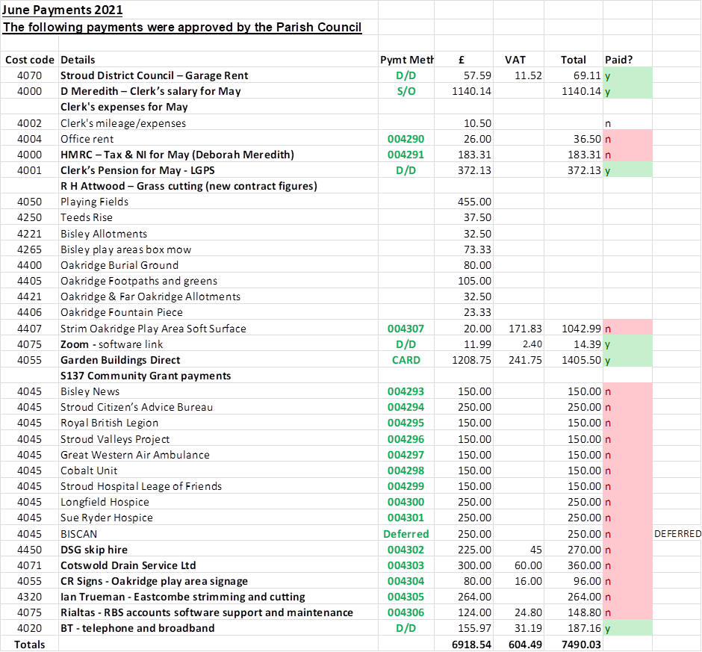
11. Correspondence – Clerk to report – Letter from the previous Eastcombe, Bussage and Browshill newsletter with a cheque for £700 was read out by the Clerk. Monies to put to good use for Eastcombe residents.

12. Ward reports –
Bisley –suggestion that we keep Teed’s Rise as a nature reserve. Met with GWT on site – ongoing. Clerk to so check with Tree Maintenance regarding a hedge on the NE boundary – they confirmed that it would work. Ward’s proposal to designate it and churchyard as a nature reserve with signs that say this and that we are managing it as such. Maintenance will continue around the edges and steps but not much more. Also an effort to be made to get a group of local people to monitor and maintain it. A group from BisCan are interested and Ward will ask for approval at the next meeting. Fences have been erected high in the Mount Pleasant area – this has been reported to SDC.
Oakridge – Seat in Far Oakridge needs repair. The donors have removed the name plaque from it and ME asked for it to be made safe. DR will look at it. No reply has been received at present from Sapperton Parish Council with regard to proposed mast despite emailing 3 times to find out their view. Verges were covered elsewhere this evening. Bonfires have cropped up again this time with abusive comments to a person – now dealt with and apologies given. Election expenses are required tomorrow by SDC. Lastly, a ‘no dogs’ sign on the Oakridge school playing field has been set up.
Eastcombe – spoil from Hawkridge in Fidges Lane is being taken down to a field opposite Aberlink on The Vatch. Residents had complained to the Clerk also about large loads being moved along Fidges Lane. Paul Bowden returned to DM a short list of questions who included JE as Ward Councillor to respond. Fort View has submitted an appeal again to the secretary of state which requires further information by 3rd week June please, to JE. Land at Middle Hill has a time extension to June 25th on it. Thomas Keble has no application to date, but PC is involved. LW will hopefully be on the planning going forward. JE stated that she can’t find policies on website, ME confirmed this is a problem is and hopefully something will soon be in place to sort it out.

13. Date/location/format of Next Meeting – Chair.
Next full Parish Council meeting is at 7:30 on 7th July at Bisley Village Hall. Clerk to recommence bookings.

The meeting ended at 9:15
Annex A to the minutes.
DISTRICT COUNCILLOR’S REPORT

I am very pleased to be the new District Councillor for Bisley, Eastcombe and Oakridge, and I look forward to representing all residents of the Ward. I have been on the Parish Council since 2018, and I plan to continue on it as well as the District Council. I hope this will enable me to better represent local interests at the District level. I will be on two Stroud District Council committees: Environment (responsible for waste and recycling, environmental health, canals, and carbon management, inter alia) and Development Control (planning). My priorities include helping the area and its residents respond to the challenges of climate change; protecting our beautiful environment; supporting the more vulnerable and those in need; making our roads safer for all; and supporting local businesses.

I and my wife Leigh have lived in Bisley for five years, but we have known the area well since my parents came to live here 30 years ago. I am a former teacher, a cyclist and bell-ringer, and a keen gardener, growing much of my household’s fruit and vegetables – with plenty of the excellent local compost from Bisley Community Composting Scheme. I helped start the local climate action group BisCAN, as well as a community speedwatch group in Bisley, and remain active in both.

Please don’t hesitate to tell me anything you think I should be taking up at the District Council.

Martin Brown
May 25th, 2021

