BONFIRE BAN DURING LOCKDOWN 3
The Parish Council requests that tenants do not have bonfires during the current lockdown period on its allotment sites.

Covid-19 is a respiratory disease. People with underlying health conditions have been advised to self-isolate in their homes for 12 weeks. They need to go into their outside space for fresh air and open windows for ventilation.
Smoke from bonfires may cause problems for people with underlying health conditions such as asthma, bronchitis and heart conditions, so causing an extra burden on the NHS.
DO NOT BURN
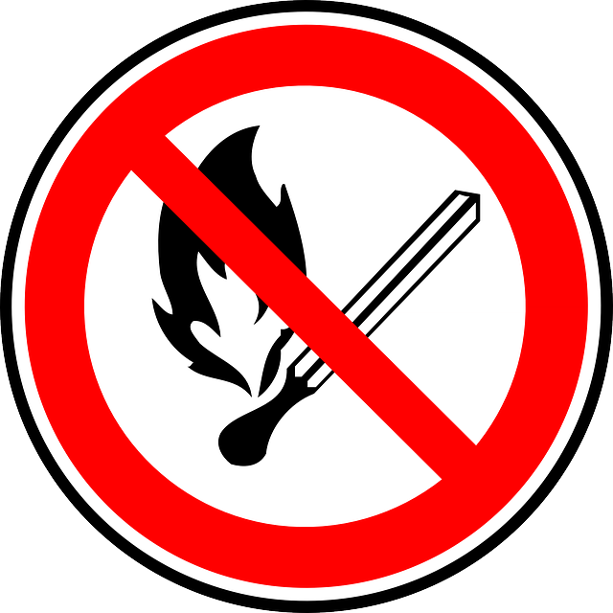

Parish Clerk for Bisley-with-Lypiatt Parish Council
11th January 2021

